Source Data Mapping Approach to CDMV5.4

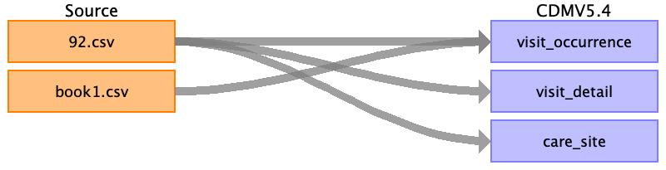

Table name: person

Table name: observation_period

Table name: visit_occurrence

Reading from book1.csv

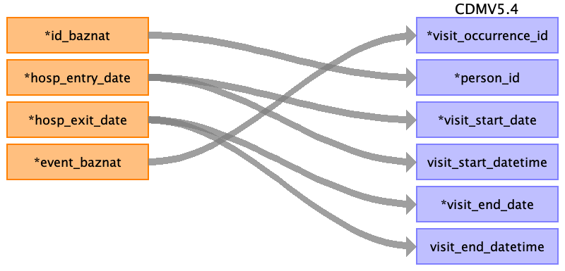

|  |  |  |  |
| --- | --- | --- | --- |
| Destination Field | Source Field | Logic | Comment |
| visit_occurrence_id | event_baznat |  |  |
| person_id | ﻿id_baznat |  |  |
| visit_concept_id |  |  | 9201 |
| visit_start_date | hosp_entry_date |  | Date and time - DD/MM/YYYY HH:MM:SS |
| visit_start_datetime | hosp_entry_date |  | Only date DD/MM/YYYY |
| visit_end_date | hosp_exit_date |  | Date and time - DD/MM/YYYY HH:MM:SS |
| visit_end_datetime | hosp_exit_date |  | Only date DD/MM/YYYY |
| visit_type_concept_id |  |  | EHR_concept_id 32817 |
| provider_id |  |  | Not know! |
| care_site_id |  |  | Based by the care_site table and event baznat. |
| visit_source_value |  |  | Not use in this field. |
| visit_source_concept_id |  |  | Not use in this field. |
| admitted_from_concept_id |  |  | 0 |
| admitted_from_source_value |  |  | Not use in this field. |
| discharged_to_concept_id |  |  | Not use in this field. |
| discharged_to_source_value |  |  | Not use in this field. |
| preceding_visit_occurrence_id |  |  | Not use in this field. |

Reading from 92.csv

Generated

|  |  |  |  |
| --- | --- | --- | --- |
| Destination Field | Source Field | Logic | Comment |
| visit_occurrence_id |  |  |  |
| person_id |  |  |  |
| visit_concept_id |  |  | 9201 |
| visit_start_date |  |  | Date and time - DD/MM/YYYY HH:MM:SS |
| visit_start_datetime |  |  | Only date DD/MM/YYYY |
| visit_end_date |  |  | Date and time - DD/MM/YYYY HH:MM:SS |
| visit_end_datetime |  |  | Only date DD/MM/YYYY |
| visit_type_concept_id |  |  | EHR_concept_id 32817 |
| provider_id |  |  | Not know! |
| care_site_id |  |  | Based by the care_site table and event baznat. |
| visit_source_value |  |  | Not use in this field. |
| visit_source_concept_id |  |  | Not use in this field. |
| admitted_from_concept_id |  |  | 0 |
| admitted_from_source_value |  |  | Not use in this field. |
| discharged_to_concept_id |  |  | Not use in this field. |
| discharged_to_source_value |  |  | Not use in this field. |
| preceding_visit_occurrence_id |  |  | Not use in this field. |

Table name: visit_detail

Reading from 92.csv

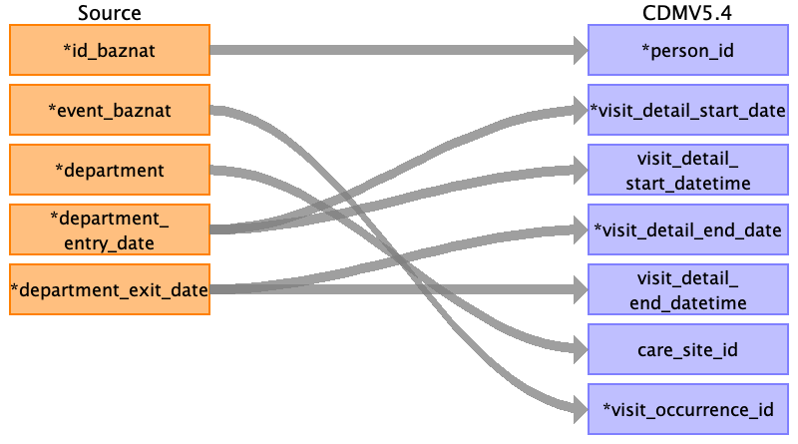

|  |  |  |  |
| --- | --- | --- | --- |
| Destination Field | Source Field | Logic | Comment |
| visit_detail_id |  |  | ID run |
| person_id | ﻿id_baznat |  |  |
| visit_detail_concept_id |  |  | InpatientVisit_concept_id 9201 # Inpatient Visit, according to: https://ohdsi.github.io/CommonDataModel/cdm53.html#VISIT_DETAIL |
| visit_detail_start_date | department_entry_date |  | Only date DD/MM/YYYY |
| visit_detail_start_datetime | department_entry_date |  | Date and time - DD/MM/YYYY HH:MM:SS |
| visit_detail_end_date | department_exit_date |  | Only date DD/MM/YYYY |
| visit_detail_end_datetime | department_exit_date |  | Date and time - DD/MM/YYYY HH:MM:SS |
| visit_detail_type_concept_id |  |  | EHR_concept_id 32817 |
| provider_id |  |  | Not know! |
| care_site_id | department | care_site_id care_site_name visit_detail_source_value  1 Maternity-stay יולדות-השהייה  1 Maternity-stay יולדות- השהייה  2 Unit on Ein Kerem יחידת על ע"כ  3 Infants A Class תינוקות א' מחלקה  4 Har HaTsofim babies תינוקות ה"צ  5 High-risk pregnancies in women הריון בסיכון גבוה בנשים  6 Infants B. Class תינוקות ב' מחלקה  7 Pregnancy Complications - Har HaTsofim Department סיבוכי הריון - מחלקה ה.צ  8 Intermediate Maternity (DRG) יולדות ביניים )DRG(  9 Maternity A. Har HaTsofim יולדות א ה.צ  10 Intensive care of the Har HaTsofim newborn טיפול נמרץ בילוד ה.צ  11 Preterm infants Har HaTsofim Department פגים מחלקה ה.צ  12 Maternity B. Department יולדות ב' מחלקה  13 High-risk pregnancy in childbirth הריון בסיכון גבוה ביולדות  14 Maternity A Class יולדות א' מחלקה  15 Babies C Class תינוקות ג' מחלקה  16 Intensive care 7 Outbreak disease טיפול נמרץ 7 מחלה מתפרצת  17 Internal Medicine Outbreak Disease - 5A מחלקה פנימית מחלה מתפרצת - 5א'  18 Women's Ein Kerem Department נשים מחלקה ע"כ  19 Maternity C Class יולדות ג' מחלקה  20 Maternity on Har HaTsofim יולדות ב ה.צ  21 Neonatal Intensive Care טיפול נמרץ יילודים  22 Special care for the Ein Kerem newborn טיפול מיוחד בילוד ע"כ  23 Surgery A. Har HaTsofim Department כירורגיה א מחלקה ה"צ  24 Gynecology Har HaTsofim Department גינקולוגיה מחלקה ה"צ  25 Pediatric Intensive Care (Lev) Ein Kerem טיפול נמרץ ילדים )לב( ע"כ  26 Ein Kerem Pediatric Intensive Care טיפול נמרץ ילדים ע"כ  27 Neurology Department Ein Kerem נוירולוגיה מחלקה ע"כ  28 General Surgery A. Ein Kerem כירורגיה כללית א' ע"כ  29 Surgery in the Har HaTsofim Department כירורגיה ב מחלקה ה"צ  30 Unit on Har HaTsofim יחידת על ה"צ  31 Internal ward Outbreak disease 4 d מחלקה פנימית מחלה מתפרצת 4ד'  32 Boarding school C. Ein Kerem פנימית ג' ע"כ  33 Intensive care recovery טיפול נמרץ בהתאוששות  34 Pediatric Surgery - Chest and Heart Department Ein Kerem כירורגית ילדים - חזה ולב מחלקה ע.כ  35 Ein Kerem Heart Unit יחידת הלב ע"כ  36 Cardiology קרדיולוגיה  37 General Surgery B. Ein Kerem כירורגיה כללית ב' ע"כ  38 Urology Department Ein Kerem אורולוגיה מחלקה ע"כ  39 Intermediate-Internal Therapy B טיפול ביניים-פנימית ב'  40 Skin and Sex Department Ein Kerem עור ומין מחלקה ע"כ  41 The stay - Ein Kerem השהיה - ע"כ  42 General Intensive Care Area 2 טיפול נמרץ כללי אזור 2  43 Boarding School A. Ein Kerem Department פנימית א' מחלקה ע"כ  44 Intensive Care 3rd floor Har HaTsofim ט.נמרץ כללי קומה-3 ה"צ  45 Hematology Department Ein Kerem המטולוגיה מחלקה ע"כ  46 Intensive Care 4rd floor Har HaTsofim ט.נמרץ כללי קומה-4- ה"צ  47 Orthopedics Har HaTsofim Department אורתופדיה מחלקה ה.צ  48 The stay - Har HaTsofim השהיה- ה.צ  49 Internal Medicine Outbreak Disease 5b מחלקה פנימית מחלה מתפרצת 5ב'  50 Eating Disorders הפרעות אכילה  51 Psychiatry Department Ein Kerem פסיכיאטריה מחלקה ע"כ  52 Intensive care unit Har HaTsofim טפול נמרץ  לב יחידה ה.צ  53 Stroke unit יחידת שבץ מוחי  54 A.A.G. In Gynecology - Har HaTsofim א.א.ג. בגיניקולוגיה-ה"צ  55 Pediatric Surgery Department כירורגית ילדים מחלקה  56 Cardiology - Har HaTsofim קרדיולוגיה - ה"צ  57 Children Department Ein Kerem ילדים מחלקה ע"כ  58 Internal in the Har HaTsofim department פנימית ב מחלקה ה"צ  59 Internal Intensive Care טיפול נמרץ פנימי  60 Boarding School B. Ein Kerem Department פנימית ב' מחלקה ע"כ  61 Boarding school D. Ein Kerem פנימית ד' ע"כ  62 Vascular Surgery Department כירורגית כלי דם מחלקה  63 Pediatric Surgery - Urology Department Ein Kerem כירורגית ילדים - אורולוגיה מחלקה ע.כ  64 Neurosurgery - Children נוירוכירורגיה - ילדים  65 Orthopedics A. Ein Kerem Department אורתופדיה א' מחלקה ע"כ  66 Heart and chest surgery department כירורגית לב חזה מחלקה  67 Rehabilitation of the Har HaTsofim department שיקום מחלקה ה.צ  68 Neurosurgery Department Ein Kerem נוירוכירורגיה מחלקה ע"כ  69 ENT Department of Ein Kerem אף אוזן גרון מחלקה ע"כ  70 Oncology Department Ein Kerem אונקולוגיה מחלקה ע"כ  71 Pediatric Intensive Care - Har HaTsofim טיפול נמרץ ילדים - ה"צ  72 General Intensive Care Area 3 טיפול נמרץ כללי אזור 3  73 Children on Har HaTsofim ילדים ב ה.צ  74 Intermediate care-Internal C. Ein Kerem ט.ביניים-פנימית ג' ע"כ  75 Children - increased care ילדים- טיפול מוגבר  76 Neurosurgical intensive care טיפול נמרץ נוירוכירורגי  77 Intensive care Heart and breast surgery טיפול נמרץ כירורגיה לב חזה  78 Internal A Har HaTsofim Department פנימית א  מחלקה ה"צ  79 Eyes Department Ein Kerem עיניים מחלקה ע"כ  80 Open heart recovery התאוששות לב פתוח  81 Children A. Har HaTsofim ילדים א ה.צ  82 Har HaTsofim Maternity Rooms חדרי לידה ה"צ | Based by the care_site table and event baznat. |
| visit_detail_source_value |  |  | Not use in this field. |
| visit_detail_source_concept_id |  |  | If the VISIT_DETAIL_SOURCE_VALUE is coded in the source data using an OMOP supported vocabulary put the concept id representing the source value here. |
| admitted_from_concept_id |  |  | 0 |
| admitted_from_source_value |  |  | Not use in this field. |
| discharged_to_source_value |  |  | Not use in this field. |
| discharged_to_concept_id |  |  | Not use in this field. |
| preceding_visit_detail_id |  |  | Not use in this field. |
| parent_visit_detail_id |  |  | Not use in this field. |
| visit_occurrence_id | event_baznat |  |  |

Table name: condition_occurrence

Table name: drug_exposure

Table name: procedure_occurrence

Table name: device_exposure

Table name: measurement

Table name: observation

Table name: death

Table name: note

Table name: note_nlp

Table name: specimen

Table name: fact_relationship

Table name: location

Table name: care_site

Reading from 92.csv

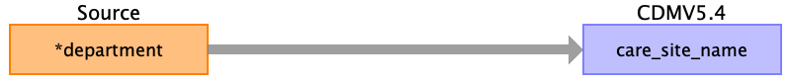

|  |  |  |  |
| --- | --- | --- | --- |
| Destination Field | Source Field | Logic | Comment |
| care_site_id |  |  | Id run |
| care_site_name | department |  |  |
| place_of_service_concept_id |  |  | concept id = 9201 |
| location_id |  |  |  |
| care_site_source_value |  |  |  |
| place_of_service_source_value |  |  |  |

Table name: provider

Table name: payer_plan_period

Table name: cost

Table name: drug_era

Table name: dose_era

Table name: condition_era

Table name: episode

Table name: episode_event

Table name: metadata

Table name: cdm_source

Table name: cohort

Table name: cohort_definition

Appendix: source tables

Table: 92.csv

|  |  |  |  |
| --- | --- | --- | --- |
| Field | Type | Most freq. value | Comment |
| ﻿id_baznat | INT | 6206416 |  |
| event_baznat | INT | 27524520 |  |
| sorter | INT | 1 |  |
| department | VARCHAR | Intermediate Maternity (DRG) |  |
| department_entry_date | VARCHAR | 04/06/2019 15:38 |  |
| department_exit_date | VARCHAR |  |  |

Table: book1.csv

|  |  |  |  |
| --- | --- | --- | --- |
| Field | Type | Most freq. value | Comment |
| ﻿id_baznat | INT |  |  |
| mother_id_baznat | INT |  |  |
| hosp_entry_date | INT |  |  |
| hosp_exit_date | INT |  |  |
| event_baznat | INT |  |  |
| emg_event_baznat | INT |  |  |
| cham_hosp_entry_date | INT |  |  |
| cham_hosp_exit_date | INT |  |  |
| age_category | INT |  |  |